Lecture 08: Specification Sheet

Topic: Five Layer Drop-Down Menu Using Flexbox, ul, li, a Structure with Icons

1. Lecture Information
Item | Details
Lecture No | 08
Topic | Five Layer Drop-Down Menu
Main Technology | HTML5 + CSS3
Layout System | Flexbox
Structure | nav > ul > li > a
Icon Used | <i class="fas fa-chevron-down"></i>
Menu Type | Multi-Level Drop-Down
Total Layers | 5 Layers
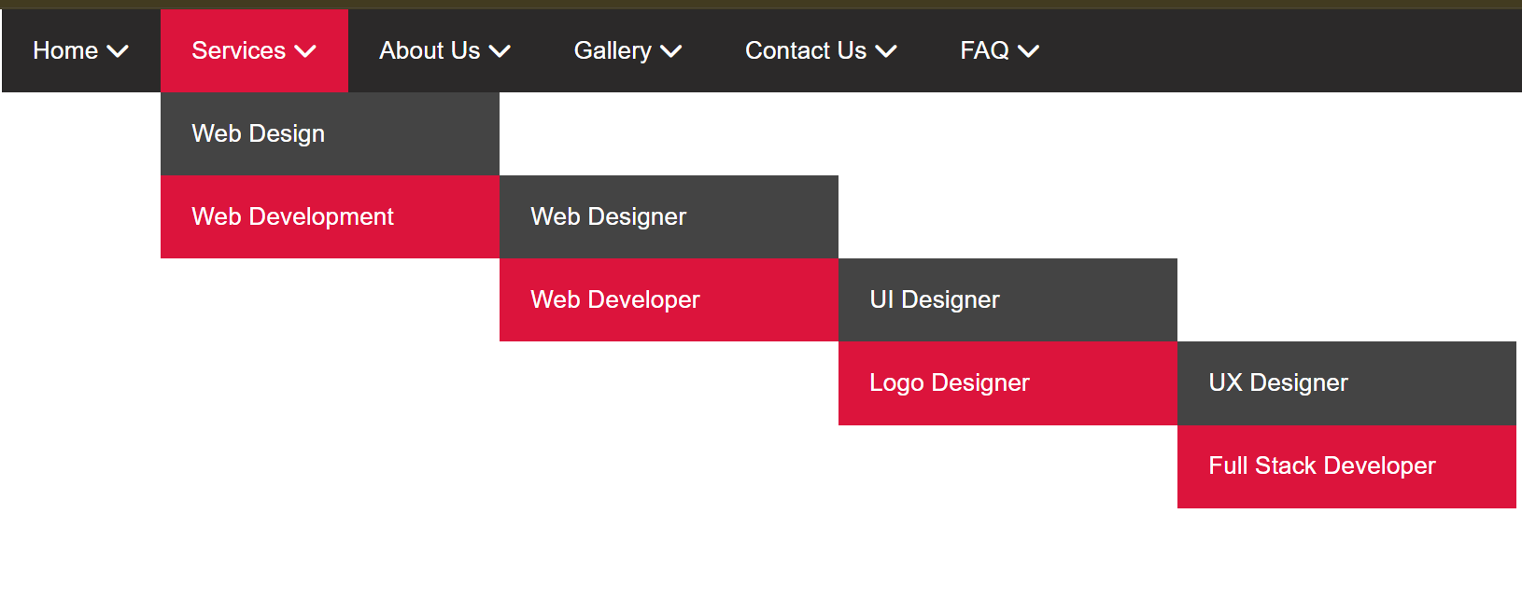

2. Learning Objectives
After completing this lecture, students will be able to:
- Create navigation menus using semantic tags
- Build multi-level drop-down menus
- Use Flexbox for horizontal menu alignment
- Create nested ul and li structures
- Add Font Awesome icons
- Use position: relative and position: absolute
- Show and hide drop-down menus using :hover
- Design a five-layer menu system

3. Required Technologies
Technology | Purpose
HTML5 | Menu Structure
CSS3 | Styling and Hover Effects
Flexbox | Horizontal Alignment
Font Awesome | Drop-Down Icons

4. Semantic Structure
<nav class="menu">
<ul>
<li>
<a href="#">
Home
<i class="fas fa-chevron-down"></i>
</a>

<ul>
<li>
<a href="#">Layer 2</a>

<ul>
<li>
<a href="#">Layer 3</a>

<ul>
<li>
<a href="#">Layer 4</a>

<ul>
<li>
<a href="#">Layer 5</a>
</li>
</ul>

</li>
</ul>

</li>
</ul>

</li>
</ul>

</li>
</ul>
</nav>

5. HTML Elements Used
Element | Purpose
<nav> | Navigation container
<ul> | Unordered menu list
<li> | Menu item
<a> | Clickable menu link
<i> | Font Awesome icon

6. Flexbox Usage

Main Menu Flexbox
.menu > ul{
display: flex;
}

Purpose
- Align menu items horizontally
- Create responsive navigation layout

7. Position System
Property | Purpose
position: relative | Parent reference
position: absolute | Child drop-down positioning

8. Why Use position: relative?
.menu ul li{
position: relative;
}

Reason
- Absolute child follows nearest relative parent
- Every submenu opens from its parent item

9. Why Use position: absolute?
.menu ul ul{
position: absolute;
}

Reason
- Remove submenu from normal document flow
- Place submenu beside or below parent menu

10. Basic CSS Structure
*{
margin:0;
padding:0;
box-sizing:border-box;
}

body{
font-family:arial;
}

.menu ul{
list-style:none;
}

.menu > ul{
display:flex;
background:black;
}

.menu ul li a{
color:white;
text-decoration:none;
padding:15px 20px;
display:block;
}

.menu ul li:hover{
background:crimson;
}

11. Hide All Submenus
.menu ul ul{
display:none;
}

Purpose
- Hide nested menus initially

12. Show Submenu on Hover
.menu ul li:hover > ul{
display:block;
}

Purpose
- Show submenu when mouse hovers parent item

13. First Layer Drop-Down Position
.menu ul ul{
position:absolute;
top:100%;
left:0;
background:black;
min-width:220px;
}

Result
- Submenu opens below parent menu

14. Second to Fifth Layer Position
.menu ul ul ul{
top:0;
left:100%;
}

Result
- Next submenu opens right side of parent submenu

15. Full Five Layer Structure
Layer | Position
Layer 1 | Main Menu
Layer 2 | Below Layer 1
Layer 3 | Right Side of Layer 2
Layer 4 | Right Side of Layer 3
Layer 5 | Right Side of Layer 4

16. Font Awesome Icon Setup

CDN(Content Delivery Network) Link
<link rel="stylesheet"
href="https://cdnjs.cloudflare.com/ajax/libs/font-awesome/6.5.1/css/all.min.css">

17. Icon Example
<a href="#">
Services
<i class="fas fa-chevron-down"></i>
</a>

18. Icon Styling
.menu ul li a i{
margin-left:5px;
font-size:12px;
}

19. Important CSS Properties
Property | Function
display:flex | Horizontal menu
display:block | Full clickable area
position:absolute | Drop-down control
position:relative | Parent reference
top:100% | Open below
left:100% | Open right side
display:none | Hide submenu
:hover | Show submenu

20. Hover Selector Explanation
.menu ul li:hover > ul

Part | Meaning
.menu | Main navigation
ul | Menu list
li:hover | Hovered item
> | Direct child selector
ul | Direct submenu

21. Why Use > Sign?

Example
.menu ul li:hover > ul

Meaning
- Select only direct child submenu
- Prevent all nested menus from opening together

22. Advantages of Flexbox Menu
- Easy horizontal alignment
- Clean responsive structure
- Flexible spacing control
- Better modern layout system
- Easier menu management

23. Common Mistakes
Mistake | Problem
No position: relative | Submenu moves wrong place
Missing display:block in a | Small clickable area
Forget display:none | All submenu visible
Wrong hover selector | Menu flickering

24. Best Practices
- Use semantic <nav>
- Keep clean nested structure
- Use meaningful menu names
- Maintain proper indentation
- Use Flexbox for top menu
- Use consistent spacing

25. Final Concept Summary
A five-layer drop-down menu uses:
- Semantic HTML structure
- Nested ul and li
- Flexbox for main menu
- Absolute positioning for submenus
- Hover effect for interaction
- Font Awesome icons for UI indication
The combination creates a professional multi-level navigation system for websites.

